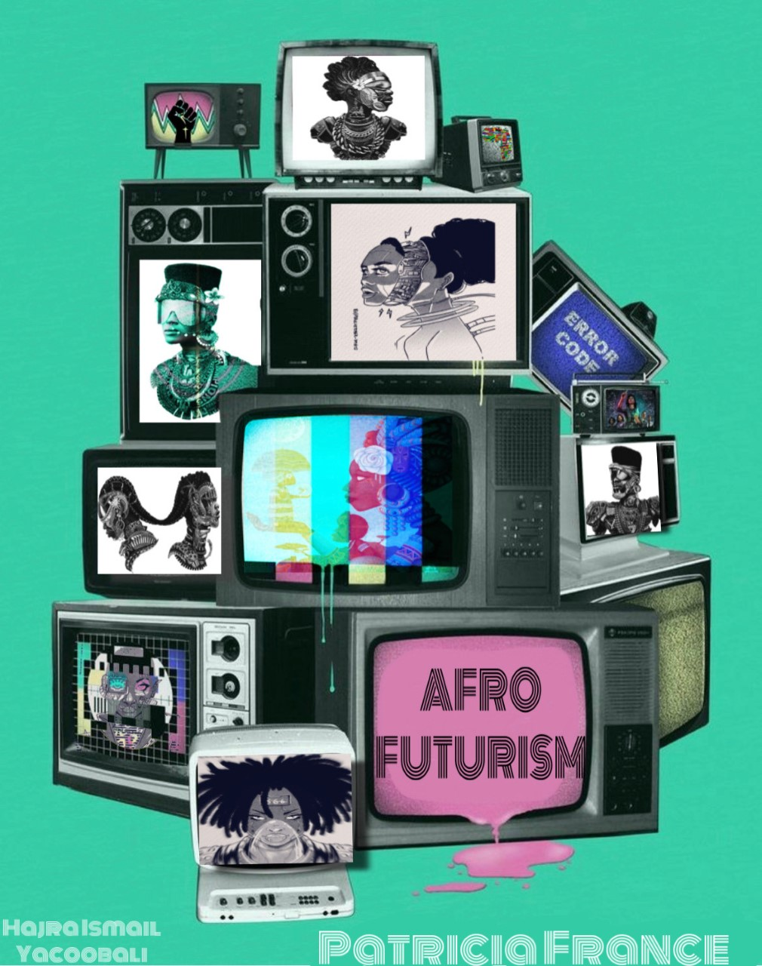

Afrofuturism Across the African Diaspora: Empowering Black Students Through Literature

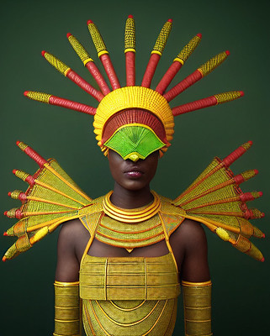

Afrofuturism interpretation by Solen Feyissa

licensed under CC BY-SA 2.0

Authors: Patricia France, English Instructor and Hajra Ismail Yacooboli, Research Assistant

Peer Reviewed: First Edition

# Preface

*I want to be a writer.*

While teaching my literature course that focused on Afrofuturism, one of my African-American students, who was also an athlete, began reading *Parable of the Sower* by Octavia Butler. This student had taken my class before and struggled with bringing their voice in academic writing. The doubt always plagued this student. They had a wonderful perspective when writing about race and mental health. We would sit and form their outline verbally and then their ideas came together. They were able to form a community in their assigned group and predict themes in the book. With a little encouragement, examples and one-on-one support, the student continued to improve in their writing. During our time studying Afrofuturism, they began to participate more in class and discussing the different themes of power, science, and love while reading literature by Afrofuturist and Africanfuturist authors.

One day, this student came to class early while I was setting up. We were discussing *Parable of the Sower* and the character Lauren’s age but level of maturity during a difficult time. The student had finished reading the book three weeks ahead of the class. They had started to think about becoming a writer, which had prompted them to start journaling. They later started bringing a journal to class, and I could see the student journaling in class (the student struggled mentally, so I allowed them to decompress whenever they needed). I began to witness a change in the students’ interest in reading and writing. A leader in the athletic department told me the student carried the book everywhere and discussed the themes with them. The student was more focused reading *Parable of the Sower* than other homework in another class. The student stated after reading and learning about Octavia Butler they wanted to become a writer. There was still doubt. Of course, I said “Yes, you can become a writer”. I dispelled the student’s doubt and highlighted the positive changes that had surfaced in the student’s writing. I could see it in the student’s reflection in homework and class assignments. There was a connection the student was making in their lives and taping into their own creativity. Afrofuturism literature can inspire students’ to nurture their writing talents and gifts.

During a community college event regarding policing, a former in class tutor and I began discussing school and their future. This student, an advocate for environmental issues and justice, was intrigued by my course’s focus on Afrofuturism and literature. The student did not know about the genre. As I described its connections to the film *Black Panther*, the student became intrigued. They wanted to learn more. We spoke more about their interest in comics and connecting to their Asian heritage. I explained the importance of Afrofuturism to Black students and all students. Although I knew this student as a tutor, that short conversation about Afrofuturism opened the door to conversations about representation for the Asian community on campus and her love of comics. Afrofuturism is an opening for a student who is naturally looking towards the future for cultural and environmental reasons. The introduction to this theme opened their eyes to the possibilities. Later we continued the dialogue as I worked with her to form the first Asian Pacific Islander Desi Americans (APIDAs) club at our college campus. As we continued to collaborate, my research began to connect to other communities that embrace this genre and I discovered connections between [**Asian Futurism and Afrofuturism**](https://planamag.com/time-for-new-dreams-lessons-from-techno-orientalism-and-afro-futurism/)**, which I shared with this student.**

Afrofuturism is important because it offers a chance to continue to dream. Representation matters in many different forms. In academia there are canons of literature that center whiteness, but we need to engage students in new ways that connect to their world now. As instructors who are looking for topics to engage our many diverse students, there is beauty in using Afrofuturism in a college literature course. In this setting, students can bring their culture, ideas, and dreams to the page. There are writers who use their culture to encourage the next generation. These two examples highlight ways that Afrofuturism can change the narrative for students of many diasporas and create leaders and writers.

## Letter to Faculty

Welcome to this journey of inspiring Black students to see themselves as part of a rich history of writing innovation and manifesting their futures. During the pandemic, the world was paused, with all teachers and students trying to find a way to continue to learn in this “new” future and “historical” event. As instructors, we had to learn how to teach again online virtually while many our sanctity and question the future like our students. Now that we are back in person, the educational landscape for Black students is still changing. How do we inspire new ways of hope?

I am a writing instructor focused on hope and offering our students a new future through writing. During my experience teaching during the pandemic, I witnessed many students experience mental health challenges due to social unrest with the killing of George Floyd. I also saw the diverse ways that protests for Black lives manifested as wellness for the next generation of Black students. While experiencing the wildfires in Northern California and waking up to a haze of yellow skies from burning trees and the political climate, I found myself reading *Parable of the Sower* and revisiting Octavia Butler’s story of the individual heroine and the power of “Change.” As I taught my students this prophetic book, even with the world on fire outside, the students saw hope in the heroine, and they saw themselves in the book. As an instructor, I continued to discuss how even amid troubles, they still have a voice and they are part of the movement more community for the future.

Octavia Butler influenced a dive into Afrofuturism during the pandemic and brought the writing to my English literature course. The course highlighted different genres: short stories, poetry, and fiction. Each unit highlighted several Afrofuturistic aesthetics. Students explored each genre, whether explicitly Afrofuturistic text or not, and how they could use this lens to analyze literature. The message of this topic for Black students is, “Afrofuturism is not just about creating imagined worlds; it can also offer an escape from real-world troubles or can be used as a way of examining the problems that African-Americans currently face in the world” (Washington). The pandemic highlighted this on the news and with the medical injustice, economic inequality, and who has access to mental health services. Through Afrofuturistic writers, black students are taken out of the everyday trauma and given new leaders to aspire to: Ytasha L. Womack, Ta-Nehisi Paul Coates, N.K. Jemisin, and Colson Whitehead. These writers are paving the way for the continued renaissance of black writers in science fiction and fantasy. Students are finding empowerment in creating a better future and fighting against the image of Black people and what they can become. Again, Black people find ingenuity in the face of barriers, “Afrofuturists frequently acknowledge their ancestors and illustrate the ways that the past is a continuing influence on the present”(Washington). As a Black instructor, woman, and empath teaching students from all backgrounds, I am aware of the impact of the literature I present in the classroom. I instantly remember the research on how Black students are impacted by the constant reminder of the trauma of their ancestors’ experience while discussing African-American history. How do I build respect for the past but build hope in the classroom? I don’t want to continue the problem, considering I know what it's like to be the only Black student in a classroom discussing race. Teaching this course and theme continues with the further research of culturally responsive pedagogy and Afrofuturism.

## Inspiration

After returning to the classroom during the pandemic, the influx of banned books focuses on marginalized communities and sanitizing Black history. This action is a new form of injustice that Black students face. They are battling the erasure of their history, which requires them to fight for the future. As the creator of *The 1619 Project,* Nikole Hannah-Jones was denied tenure at a prominent university*;* it is noteworthy to understand the past and the present social unrest. I am aware of making sure Black students can see themselves as fighters and continue the future their ancestors survived for today—one day, during a discussion of the “Self-defense” chapter of *The 1619 Project*, students brainstormed ideas and themes in groups. Many key topics focused on the brutality and injustices Black people faced in the United States. While looking at the list, it was sad and created a narrative that Black people did not have a voice. Again, as an instructor, how do I change these narratives to continue to respect the past but encourage the next generation of black students to see themselves in the classroom in a positive way

In the next class period, I presented a different video of the chapter and shifted how I showed the text to my students and the effects on Black and Brown students for "Self-Defense." I shared an image of Dr. Martin Luther King’s statue in Washington D.C. at the National Mall with his arms crossed and discussed the significance of that image. In addition, there any controversies over the image and what Dr. Martin Luther King represented for the Civil Rights movement, how Malcolm X influenced self-defense, and the erasure of Slave revolts. The Liberation topic was addressed while watching *The 1619 Project* “Fear” episode on *Hulu*. As my students discussed the “Fear” episode with a connection to self-defense, I asked them, “What does liberation mean to you?”. As some students shared their ideas, one of my Black male students on the basketball team raised his hand and shared that “Liberation is different from freedom…even though you are free, it doesn’t mean you are liberated." That’s it! I was proud that this young student brought an explanation that would launch many political movements. Inspired by this statement, I discussed Black resistance and shared examples of resistance: bus boycotts, HBCUs, great migration, and Black Panthers. These are all examples of ways Black people resisted and liberated themselves. As a result of the decision, the same Black student and another student of color began to think about this topic for their research paper.

This story’s real-life teaching experience inspired me to think about Afrofuturism and its message applied to all literature, with a shift in discussion about Black resistance. Black students can reimagine their history differently. Yes! Black people continue to heal the generational trauma of being enslaved. We have to continue to discuss that history. Still, we can also honor our heroes and ancestors with continuity to live, create a better world for our future, and empower Black young adults to fight white supremacy by dreaming of a better life. Literature can open their imagination. Afrofuturism gives young Black leaders a way to acknowledge and see themselves creating a new legacy and history with joy, creativity and focus on continuing to thrive in the future, and what better way than to use literature as a permanent way to create and manifest our new destiny?

# Chapter One: An Introduction to Afrofuturism

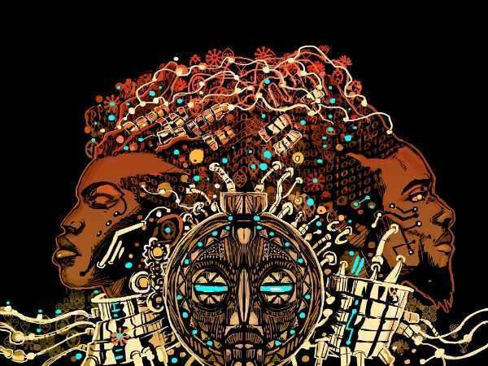

Front and back cover of [The Black Speculative Arts Movement](https://amzn.to/3cdE4Lw) edited by Reynaldo Anderson and Clinton R. Fluker—John Jennings

#### Key Faculty Insights:

* Complexity of Afrofuturism
* Provide a definition of Afrofuturism
* The importance of Afrofuturism in literature

## Introduction

The term Afrofuturism was coined during the 1970’s and was “invented by author, critic, and essayist Mark Dery in 1993 [in his book *Flame Wars: The Discourse of Cyberculture* and chapter “Black to the Future”] and refined by other scholars in the late 1990s and early 2000s. It is enjoying new popularity in mainstream media” (Adiele). Afrofuturism has expanded into different forms of literature with the declaration of Mark Dery’s label of Afrofuturism. This text uses this theme for the new generation of Black students to continue the tradition with their technology and use of social media. This new popularity is the perfect foundation for them to see themselves positively. They are trying to make a future for themselves and what THEY see as a future. As educators, we continue to see students experience many challenges, the pressure to keep up with the hustle, and the need to move forward in this fast-paced life.

*Why Afrofuturism in Literature Class?*

African-American students need spaces to envision a new future for themselves. Afrofuturism is “an aesthetic that uses the arts, science, technology, and history to reimagine Black futures” (Adiele). There was always a desire to change the narrative to create a better life. Young African-American students and young adults want to see themselves in a positive light. They are trying to make a future for themselves and what they see as a future. Afrofuturism will continue to blend the next generation of African-Americans and the ever-changing use of technology, science, art, and history.

Literature and the creativity of Afrofuturism can give our Black students a journey of joy.

Afrofuturism literature can have our future focus more on creating and using this literature to tackle complex concepts but with joy as the focus and reimagining our new lives through writing. As students dive into fiction and poetry, the new space to be conquered is no longer composed of planets but of stories, those at the heart of our popular culture"(Celnik). Afrofuturism is the “rapture of joy” to the page for our young adults as they expect to define their generation in new and creative ways. Young Black students are here to live. They deserve the happiness and joy that their ancestors fought for and risked their lives to give them the future they have now. Even with the growing debate over diversity in literature courses, Black students and students of the Diaspora continue to thrive for the future. Afrofuturism literature argues that Black people can take their creative form and add their voice; no matter what planet, cosmos, or technical journey this culture will lead them. Science fiction can empower Black students to form a new destiny in honor of their ancestors.

## 

## Counterargument to Afrofuturism

What happens when Afrofuturism becomes commercialized? Afrofuturism is too idealistic and does not focus on reality. It creates a world that cannot be achieved and distracts from present day societal problems. As this genre has become popular, the counterargument continues as Afrofuturism is highlighted in the media and films with popularity taken from the culture to empower mainstream money makers. This focus on the genre has consequences. Some critics of the popularity of Afrofuturism are warning of losing its purpose. Nilé Livingston, artist, and entrepreneur, quotes on their blog: My mentor, Denise cites communications professor Jarad Ball who would suggest that this is intentional: On a podcast, he showed how popular culture was ‘crushing the potential for radicalism.’ This is done by giving Black people the representations they desire, but only symbolically, with no real redress of the issues they are confronted with. This quote and perspective on the popularity of Afrofuturism is still unclear. With the wave of movies, music, artwork, and further research from scholars, it is still an aesthetic to continue to persuade and allow the next generation to move forward. It was born out of Black creatives not seeing representation in Science fiction and using the genre as faith for the future. As technology grows and with the beginning of this course, hopefully the next generation of Afrofuturist will add their “generational” touch, and it will continue. Commercialization will only last for some time and then move on to the next thing. However, Afrofuturism was born out of resistance and will continue to resist being lost. Afrofuturism is not the same as it was in the 1970s. What it will become in this next resurgence can be empowering and not lost to commercialism.

## African Futurism

Afrofuturism is being led by the popularity of art, film and music, translating into the resurgent popularity of books like *Kindred*. The leading writers of Afrofuturism are also part of Africa Futurism. They are women of African background and give another perspective in their stories for young adults and college students. In the *African Futurism: An Anthology*, Nnedimna Nkemdili “Nedi” Okorafor, Nigerian American writer, shares the distinction between Afrofuturism and African Futurism. Here is the author's explanation, “African Futurism is similar to ‘Afrofuturism’ in the way that Blacks on the continent and in the Black Diaspora are all connected by blood, spirit, history, and future. The difference is that African Futurism is specifically and more directly rooted in African culture, history, mythology, and point-of-view as it branches into the Black Diaspora. It does not privilege or center the West” (Okorafor). The two genres serve the same purpose for students studying literature. It gives another view of culture and how each pulls Black people to a more secure future.

## African Diaspora

Afrofuturism embraces all links to the diaspora and wants to see all in the African community thrive. For Black students, seeing people like them in these creative works is important and a bridge to connect to their history. Black people are not only in the future but globally influential in multiple parts of the world. Afrofuturism is extended to all aspects of the African Diaspora:

What is the African Diaspora? The origin of the African Diaspora begins with the dispersal of African peoples out of the African continent. There have been four major dispersals of people out of Africa: the spread of humanity from its origin in Africa; the spread of civilization from the Nile Valley and other African empires; the spread of traditional African culture because of the European slave trade; and migration out of modern Africa (Alkalimat).

It is important for Black students to expand their minds towards the future and connect to others in the community. Afrofuturistic aesthetic shows them they are not alone in the written form and allows them to continue manifesting Black creativity. Afrofuturism is diverse in literature and this faculty handbook provides an initial preview of the roadmap for a series of editions to follow. There are many African-American and African writers creating works that focus on culture, technology, and social issues and topics that college students can use for their critical writing and research.

# Chapter Two: Afrofuturism Aesthetics

Hoberman, J. “‘Space Is the Place’ Offers Otherworldly Takes on Identity.” 
The New York Times, 2 Apr. 2015

Hoberman, J. “‘Space Is the Place’ Offers Otherworldly Takes on Identity.”

*The New York Times*, 2 Apr. 2015

#### Key Faculty Insights:

* How to empower Black students
* Finding purpose in Afrofuturism for students
* What are the Afrofuturism techniques in literature

# Afrofuturism Aesthetics

Redefining the future with Afrofuturistic writing is multi-dimensional. As we enter the story, we are drawn into the author's consciousness and intentions from the first line or plot twist. As readers, we are embraced in this world of technology intertwined with Black experience and cultures. How are short stories connected to this theme of Afrofuturism? In the article: “Time-Sensitive: Teaching Afrofuturism through the Nineteenth Century'', "My goal in teaching a long history of Afrofuturism was to suggest that the kinds of aesthetics we see in contemporary Afrofuturist literature, television, and film have a compelling and important tradition in Black American literary history and also to show that it has deep roots in Black political history" (Davoudi 33). In literary forms like short stories Afrofuturism gives the reader a short glimpse of what the future holds when considering moral challenges for the reader, the effects of technology on our lives, and what Afrofuturism is aesthetically. All with the hope of connecting to ancestry roots and philosophy that Black people are in the future. Here are some common aesthetics that can be used for the readings in this text:

* Reclaiming Identity
* Fighting Otherness
* Gender Inclusiveness
* African Symbolism
* Technology & Human Interaction Affects the Future
* Space Exploration

## A Purposeful Vision

How does the Afrofuturism Aesthetic promote empowerment in Black students in the Black tradition? Storytelling and imagination are key to engaging students in their heritage. It is passed down from generation to generation. Masiyaleti “Masi '' Mbewe, a third-year Media Studies and English student at the University of Namibia offers their insights, “Children as a norm are younger Afrofuturist. Young people can see themselves in Afrofuturism. It is a platform for Afrofuturist writers to encourage future Afrofuturistic writers' '(Mbewe). Through storytelling, Black parents, grandparents, and cousins pull from family, history, traditions, and generations during most conversations with family. Black narrators are included in literature as a start of creativity but also in music, art, and identity. In the article “‘Tell Me the Story of Home,’ Afrofuturism Eric Killinger and Black American Malaise”, Felicia L. Harris connects Afrofuturist themes and stories by asserting that “Afrofuturist storytelling traditions stem back to the 1800s; for centuries, storytellers name cornbread ideas of science and technology to re-envision histories that liberate Black futures while demonstrating how the Black subject's experience has been marked by a sense of hopelessness alienation, and dislocation”. Again, culture and history are part of Afrofuturism and healing.

Empowering Black students using their voice to tell their stories of their own experiences and generation with technology. This sense of relevance to their lives empowers them to give voice to writing about literature that centers on writers whose goal is to uplift them. My goal in teaching literature in the Afrofuturist theme was to suggest this kind of aesthetics we see in our current contemporary Black literature. Black American literary history shows Black students can use science, technology, art, and music in their ancestors' roots which was not always highlighted in science fiction literature. With the help of the spirit of Afrofuturism [Octavia E. Butle](https://www.octaviabutler.com/)r and the godfather of Afrofuturism [Sun Ra.](https://www.arts.gov/honors/jazz/sun-ra)

## 

# Chapter Three: Teaching Through the Lens of Afrofuturism



Afrofuturism Interpretation by Solen Feyissa

licensed under CC BY-SA 2.0

#### Key Faculty Insights:

* Literary Genres and Connected Themes
* Social Unrest and the Connection to Afrofuturism
* Student Activities for Community-Based Classroom

# Introduction

During the Covid pandemic, the current political struggles, the highlight of Black Lives Matter, and the resurgence of Octavia Butler's Parable of the Sower and Parable of the Talents, the changes were happening in real-time for students. Afrofuturism gives students a current connection to their world and think about a crucial question that is happening in the world. Developing arguments and using their critical lens with an Afrofuturistic lens led to a fantastic community connection for the students. As education evolves in what we should teach in the classroom and what books are allowed, the focus of Afrofuturism highlights Black students resisting the negative stereotypes or seeing themselves in literature and seeing the connection to their future with words. There are many examples of Black authors today and in the past that used literature and words as power. Ytasha L. Womack explains, “Afrofuturism is a great tool for wielding the imagination for personal change and societal growth. Empowering people to see themselves and their ideas in the future gives rise to innovation and free thinkers” (191). Is this not the goal for students? To become engaged, free thinkers and agents in their own success? Teaching Afrofuturism gives young people permission to go for their dreams. As young adults and for all of society, the struggle to find your purpose can be a challenge. It takes time.

On the page of an Afrofuturism story or poem is teaching Black students that they have a choice in their future. Again, as this curriculum continues to expand and grow. Afrofuturism fits this model of teaching in community with students because students and teachers are actively working to continue to empower students in educational settings. Afrofuturism centers on a community forwarding to the future using a variety of ways to empower students. Afrofuturism is naturally connected to creating a culturally responsive theme that will engage Black and students of color who can identify with its goal. As a community, we can build all Afrofuturism aesthetics in English courses and beyond. The classroom is a community of students who are shaping the future. African-American culture and the African diaspora is a rich culture that is highlighted in Afrofuturism literature. The world is open with these imaginative authors who over decades as far back as W.E.B. DuBois’s “Comet” features a radical discussion of race, racism, identity, science, and folklore, and many of your Black students have access to this tradition and ancestral freedom.

## Short Stories: Identity, Symbolism, and Voice

Short stories allow college students to analyze character plots and theme conflicts. Short stories are a condensed way for the author to bring the reader into their world. Afrofuturism short stories bring the reader into their world by focusing on themes of resistance, identity, love, and hope. The use of technology shows that Black people are part of this scientific world and have the same interest and concerns for the future. Africa itself has been documented in history for mathematics, astrology, and inventions that we are still using today. Afrofuturist writers of short stories create literature for Black people and students to enter into a world that may be fiction but can exist in them now. The short stories and authors highlighted in this section are just a snapshot of what Afrofuturism fiction writers create. The stories highlight identity, resistance, and hope. These stories offered a new future with creativity. The hope for this section is for Black youth to find inspiration to write their future as a way to find Liberation and place the way for other Black students to continue the Afrofuturism tradition. Black student writers can find joy in the future through written expression.

Short stories presented for this text are to give students a chance to reflect, analyze, and also aesthetics. Through these stories, each highlights an idea of the essence of the Afrofuturist Aesthetic. The themes are within the author's taking chances with the goals of breaking barriers in science fiction and fantasy. In the anthology *Octavia Brood*, "Kafka's Last Laugh" by B. Vagabond embraces the aesthetic of highlighting a character who fights the "Other." It gives students a vision of what could be in literature, and it gives a blueprint of what authors of color achieve in fiction and short stories.

## Suggested Readings

* “Kafka’s Last Laugh” by Beaumont Vagabond
* “Herbal” by Nalo Hopkins
* “The Book of Martha” by Octavia Butler

The symbolism of the Black fist fully raised is present in Black resistance. Black people have fought for their children to learn and expand their knowledge. Afrofuturism aesthetics help students arrive at the following key themes: Resistance, Symbolism, and Voice. These short stories and many others give students a sense of power. In including these stories, teachers may provide students a chance to develop their own voices in response to the ideas presented.

## Reading Summaries

### *[Kafka’s Last Laugh](https://icts.uci.edu/ce/ce%20material/3_Octavias%20Brood%20Readings1.pdf)* [By Beaumont Vagabond](https://icts.uci.edu/ce/ce%20material/3_Octavias%20Brood%20Readings1.pdf)

In the short story “Kafka’s Last Laugh”, by Beaumont Vagabond, the story starts with symbolic resistance. In the first paragraph the reader is given this symbol of resistance within the protagonist’s name. The story also begins with vivid images created through phrases such as “police formation” and “line of defense” and “protesters stepped forward”. The fight begins and resistance is happening. As the story continues, the main character fights for authority and control. The story ends with a revelation that is so simple the reader has a new understanding of freedom while in prison.

### [Herbal By Nalo Hopkins](https://muse.jhu.edu/pub/30/oa_edited_volume/chapter/1147107)

While the argument to fight using a simple tool when imprisoned is resistance, so is the idea of connecting with a greater meaning. In the short story “Herbal” by Nalo Hopkinson the reader is in the mind of the protagonist. The perspective is Jenny and the symbol is the elephant that mysteriously appears in her room. Through Jenny’s perspective the reader follows the internal struggle and longing of the protagonist. In the end, the reader is left waiting like Jenny.

### [The Book of Martha By Octavia E. Butler](https://www.sevenstories.com/blogs/102-an-exclusive-short-story-from-octavia-butler-in-celebration-of-her-birthday)

Afrofuturism and voice is core for literature. By giving the audience a look into what a character can do with language and dialogue, the story becomes an example of empowerment. A writer’s use of language, words and style gives voice to characters. Octavia Butler gives the character in *The Book of Martha* a strength in her personality. For example, Martha Bes character takes on the challenge of questioning God. The use of dialogue to voice the character's decision offers an argument in approaching the text as a new testament. A parable is a story, and so it is with symbolism that Octavia Butler created a new gospel.

## Sample Activities

* Each student can write a written piece of knowledge in a designated notebook on general topics, i.e., relationships, schoolwork, college struggles, and overwhelming feelings.
* Write an essay on a social justice issue and how Afrofuturism Aesthetic helps you reimagine how the world could change in the future.
* Write an essay in which you analyze, evaluate and argue for the existence of one or more aesthetics of Afrofuturism in popular culture.

## Poetry: Human Interaction, Imagery, Science

Poetry creates a story, an image, and imagination on the page. It is filled with words that transport the reader into the poet’s realm. Poetry can be embraced with metaphors so students can find their interpretation and meaning. Afrofuturistic poetry blends in the history of Black people, the play on the structure to disconnect what traditional poetry confides or organizes. Black people put their history into these poems pointing toward social justice. Black poets give our Black students the tradition of wordplay, storytelling, and artistic play with words.

Similar to rap music, poetry plays with the lyrical techniques of poetry with a broader message for the reader. Science and futurism can expand into biological science, environmental justice, technology, and dystopian images. Poetry and Afrofuturism can combine all of the elements. In the poem **“**[**My God, It’s Full of Stars**](https://www.poetryfoundation.org/poems/55519/my-god-its-full-of-stars)**” by Tracy K. Smith,** the poet connects images of God, Kubrick, and “million galaxies” by using the questions of science and native voice.

Poetry holds vivid detail. It is a roller coaster of questions, emotions and reflection. In Afrofuturism it is natural for poetry and art to connect. The structure and words can change the meaning of a poem and allow the reader to transport to another world. Afrofuturism aesthetics help bring students to this theme: Human Interaction, Science, Imagery. These poems open the creative side of students. These poems form stories in your mind in shapes, lines and colors that readers may not connect with poetry. These poems explore how we interact with each other in this greater world, universe and beyond.

## 

## Suggested Readings

* Laws of Motion by Nikki Giovanni
* My God, It’s Full of Stars by Tracy K. Smith
* Afrofuturism (Blanche says, “Meh”) by Douglas Kearney

## Reading Summaries

### [Laws of Motion By Nikki Giovanni](https://www.poetryfoundation.org/poems/48230/the-laws-of-motion)

In the poem “Laws of Motion”, movement, physical and mental is explored in this poem. This poem may not be considered an “Afrofuturism” poem, but the goal of this section and the breakdown of the aesthetics is to apply it to any poem. Especially poems that explore human connection. Nikki Giovanni in this poem dedicates the words in the beginning to “Harlem Magic”. This is in itself part of the Black history. It is also African American writers propelling to the future and giving voice to the time and generation. This poem offers the reader many levels for which students can analyze.

[My God, It's Full of Stars by Tracy K. Smith](https://www.poetryfoundation.org/poems/55519/my-god-its-full-of-stars)

In *The Book Life on Mars* by Tracy K. Smith explores the loss of her father, a scientist himself, and the mix of science and family relationships. Again, Afrofuturism is broad and can take on topics to which college students can relate. Family dynamics can be emotional. In some ways, using science, the cosmos, and planets to create some distance may be a way to share in the storytelling of family. The poem is an example of narrative as a way to engage students.

### [Afrofuturism (Blanche says, “Meh”) by Douglas Kearney](https://www.poetryfoundation.org/poetrymagazine/poems/57403/afrofuturism-blanche-says-meh)

In the poem, Afrofuturism (Blanche says, “Meh” by Doulas Kearney is a play on structure and meaning. The poem can be read on the page, but it is also an audio poem that gives students a new (technical) way to embrace poetry. The title gives the reader a hint to the meaning and the word combination, sentences, singing and connection to scientific words. In the mix of all the words is a hint of connection to African American experience.

## Sample Activities

* Students can free write answer to these questions: How would you define your generation’s future? How would you define your future?
* Students can research different planets in the solar system and use this information to create their own poems. This could be an in-class or homework assignment.
* In groups, students can review and explore the EBB Telescope: <https://webbtelescope.org/news/first-images/gallery> and take what they learned and apply it to poetry and/or create a piece of art work in homage to the poets studied.
* Student Writing Prompt #1: Write an essay on a poem that explores history, identity, self-discovery and Afrofuturism.
* Student Writing Prompt #2 Write an essay and provide analysis of a poem(s) using Afrofuturism aesthetic and compare with an artist who focuses on Afrofuturism themes, for example [Damon Davis](https://heartacheandpaint.com/Statement), [Wangechi Mutu](https://art21.org/artist/wangechi-mutu/)  or [Joshua Mays.](https://joshuamays.squarespace.com/bio)

## Fiction: History, Mystery, Survival, Hope

Fiction holds a whole world in the reader's mind. The characters, dialogue, plot, and setting can give students a clear example of what the imagination can hold for Black students. The main characters focus on leaders who are forceful, decisive, conflicted, and complex. Like short stories, fiction allows the reader to dive into the elements of charter, science, world building, language, and style. However, fiction allows readers to immerse themselves in the story a little longer and commit to the character's life. For students, fiction can be a great way to create a discussion of current topics and opens the door for students to see the issues in their own lives. Afrofuturistic fiction uses history to welcome the students in and discuss how history influences their lives today. As well as how the family, friends, and society are affected by these choices from the past. This is a way for students to dive more into how they see themselves in the world they live in today. In the common saying, “Octavia Tried to Tell Us,” her fiction tackles so many issues that today we are discussing with our students in the classroom: Climate change, political unrest, love, and family.

Fiction is like fantasy television shows and movies that inspire students to see these stories in real time. The mystery and survival are highlighted in Afrofuturism fiction because Black culture has endured so much to hold on to what was lost by enslavement. It's like uncovering the connection to the content of Africa and creating survival in stories told about people overcoming crisis, discovering their leadership skills, and building homes in unlikely places through stories. Afrofuturism in literature is born out of this continued hope for more. Students can get lost in fiction. Lost in the world. Can it be that Afrofuturistic fiction can put things in motion to come true? Similar to the original Star Trek television series, seeing a black woman, [Nichelle Nichols](https://www.pbs.org/wnet/pioneers-of-television/pioneering-people/nichelle-nichols/), as part of the main crew was part of the journey of the Civil Rights movement and pushing black people forward. This image served as hope for many young black children and the formation of [Blerds](https://afropunk.com/2022/02/oh-to-be-a-blerd-and-all-the-complexities/) for today. When fiction and Afrofuturism connect, some of the fantastical inventions and characters have come through like fortune telling. Can it be magic! If Afrofuturists create this future in literature, will it come true? Octavia Butler predicted the Northern California wildfires, the diverse community in support of survival, and the intergenerational relationships that help Earthseed survive a crisis. Octavia Butler is highlighted the most for teachers because, in her work, she was the first before many.

### Suggested Readings

* *Kindred* by Octavia E. Butler
* *Parable of the Sower* by Octavia E. Butler
* *The Fifth Season (The Broken Earth, 1)* by N. K. Jemisin (Author)

## Reading Summaries

### *[Kindred](https://www.octaviabutler.com/kindred)* [by Octavia E. Butler](https://www.octaviabutler.com/kindred)

What would you do if your family's survival depended on saving your enslaver? In *Kindred*by Octavia Butler, this question is the driving force in the reader's mind for the terror, fear, and anticipation of the main character Dana. The story confronts the history of slavery in the most direct way, and it challenges the idea of what trauma can do to a family and how it is mentally draining. Even the strongest person cannot fight what destiny has planned for the future.

### *[Parable of the Sower](https://www.octaviabutler.com/parableseries)* [by Octavia E. Butler](https://www.octaviabutler.com/parableseries)

The protagonist Lauren Olamina is set in a world in disarray and the community they are living in is holding on to some type of normalcy. Unfortunately, as the story goes along, hard choices have to be made by the young Lauren in order to survive. Ahead of her time and age, the readers are taken on a journey with Lauren. As its title hints, Parable of the Sower is layered with many meanings for Lauren and the reader. Octavia Butler takes the novel into a different interpretation of the “hero” journey and it leaves the reader questioning more than the characters' choices but the choices in their own world in real life.

### *[The Fifth Season (The Broken Earth, 1)](https://nkjemisin.com/series/the-broken-earth/)* [by N. K. Jemisin (Author)](https://nkjemisin.com/series/the-broken-earth/)

With symbolic settings like “Stillness” N. K. Jemisin masters the role of Afrofuturism and Fantasy. The main character takes the focus in this unsettling environment of disasters and tragedies, Essun is on a mission that the reader takes in over and over again. Essun is not alone in this journey in this story which may be held in the style of the author’s writing that keeps the reader engaged. What more can be endured? The story holds the reader's hope.

## Sample Activities

* Connected Future:The instructor posts a world map in the classroom and each student marks where their family is connected or they have some connection.
* Draw Your Future: In groups, students brainstorm ideas about their future using the Afrofuturism definition.
* Student Writing Prompt #1:Begin your essay by choosing a controversial topic addressed in the novel and how, in YOUR opinion, you see the future REIMAGINED through what you learned so far about Afrofuturism. You will research scholarly sources that will support your thesis and ideas about the future. For this assignment, it is optional to include some formal analysis of the novel using some fiction elements: characters, settings, plot, conflict, point of view, dialogue, and theme. (Suggested Length: 7-10 pages; Introduction, 7 or more paragraphs, and Conclusion):

# Chapter Four: Afrofuturist Aesthetic as Community-Based Teaching Approach

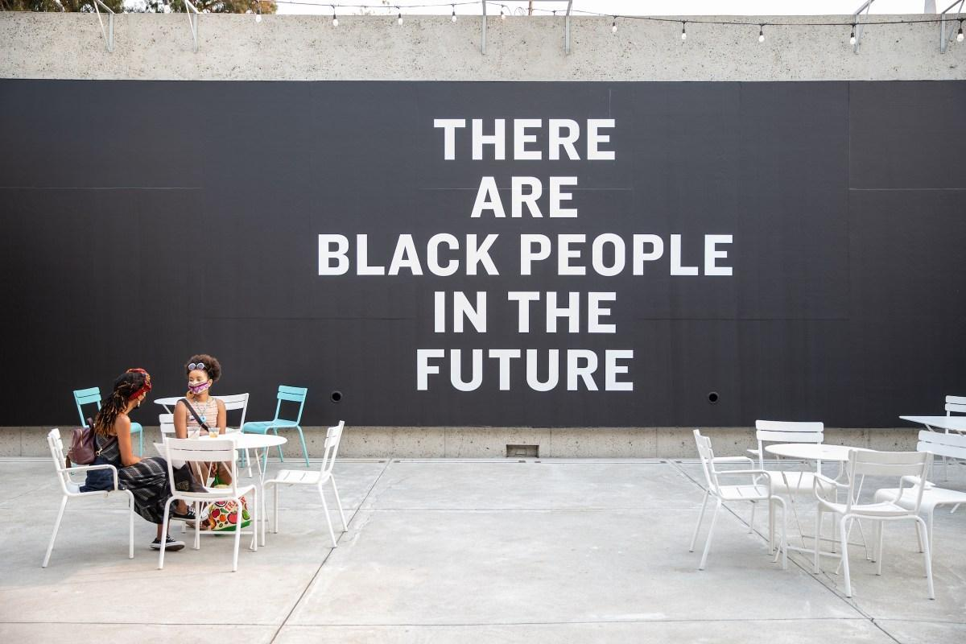

Alisha B. Wormsley, “There Are Black People in the Future” at OMCA’s Oak Street Plaza image courtesy Odell Hussey Photography (Adiele)

Key Faculty Insights:

* Growing movement towards Community-Based Classroom
* Interdisciplinary Classroom Resources
* Student Activities for Mental Health and Community-Based Classroom

## Introduction

The euphoria of the opening of *Black Panther* ushered in the not-so-new idea: “Black People are in the future.” Of course, Black people can be superheroes and scientific masterminds. While visiting the Afrofuturism exhibit at the Oakland Museum of California, *Mothership: Voyage into Afrofuturism*, the collective work of literature, music, and art displayed Afrofuturism in its diverse representation of the Black future and activism this movement was reiterated. With Oakland being the home of the Black Power political movement, [The Black Panther Party](https://nmaahc.si.edu/explore/stories/black-panther-party-challenging-police-and-promoting-social-change), founded by college students, the “mothership” landed in a city fit for it. The OMCA sees itself as both a community space and archive for Oakland, a historically Black city and incubator of Black culture and activism”(Adiele).On display at the exhibit showcases written reflections and story ideas in Octavia Butler’s handwritten notes. The collection highlights community knowledge. Nonetheless, this resource encompasses examples of literature that incorporate inclusive topics to empower Black students and for Black students to find hope in the future for themselves.

This community-based text is vital in today’s classroom. Students are creative, which gives them the agency to collaborate and create arguments about short stories, poems, and fiction in this text. Building joint agreements in every classroom is part of the activities highlighted in a community-based course. These agreements foster student engagement and help students believe they belong in the classroom. For some students, the classroom has not been a place filled with safety or peace. It has been a place filled with rules, standardized tests, and anxiety. Creating a sense of belonging in the post-pandemic classroom is crucial. In a National Public Radio broadcast, they report the growing number of students requesting mental health services as well as teachers, “In the survey, almost 30% of the schools reported that requests for mental health services from teachers and other staff are up. These statistics are another sign of the strains placed on students and educators more than three years after the pandemic began” (Levine). Yes, the community in the classroom includes students, teachers, and staff. Education is for the full development of each student, and their mental health is important.

Teaching in this “community-based” format allows students to co-create. For Black students, this enforces that their voice matters in a classroom space. Additionally, activities centering on student voice foster engagement. When students feel ownership in the classroom activities, they become active learners. Afrofuturism offers a variety of ways to empower student voices by offering culturally responsive themes that may engage Black students. As faculty, we can build Afrofuturism aesthetics into English courses and beyond.

## Suggest Readings

* An Afrofuturist School Program Empowers Children to Envision the Future
* Discussion as a Way of Teaching: Tools and Techniques for Democratic Classrooms
* Umoja Learning Community: Practices

## Reading Summaries

### [An Afrofuturist School Program Empowers Children to Envision the Future](https://www.aam-us.org/2023/03/28/an-afrofuturist-school-program-empowers-children-to-envision-the-future/)

Even though the focus of this resource is on college students, the overall message is that all ages of students need to be empowered. In this article, it is highlighted because of its creative use of Afrofuturism in more community-based projects for students. This format is more relatable for students of all ages.

Afrofuturism is reaching all educational settings: classrooms, art, and science museums. This article highlights the interdisciplinary ways of using Afrofuturism to help students succeed in more community based connections.

### [Discussion as a Way of Teaching: Tools and Techniques for Democratic Classrooms](https://www.wiley.com/en-ie/Discussion+as+a+Way+of+Teaching:+Tools+and+Techniques+for+Democratic+Classrooms,+2nd+Edition-p-9780787978082)

Community in the classroom involves students being able to discuss and share in an environment that welcomes a variety of opinions. Afrofuturism literature topics range from social, politics, and artistic. Teachers can use this text to find different ways to lead or incorporate students to lead discussions. It also addresses ways to discuss controversial topics and provides agency for all ways that students participate in the classroom. The techniques give engaging options for instructors to incorporate in a community-based classroom.

### [Umoja Learning Community: Practices](https://umojacommunity.org/umoja-practices)

As a faculty member of the Umoja learning community, it is important to create a community for my students. This learning community focuses on African-American students and other students who are connected in the community. The students are an active part of the planning, leadership, and success of the community. The practices are fundamental to giving student’s voice in an academic classroom when some student's experiences have not always been encouraged. Several fundamental practices are helpful for student success. It is a model that the student activities are inspired by in this resource.

## Student Activities

**Title:** Tree Garden

**Goal/Purpose:** This activity is to help students begin to get to know each other and feel comfortable with being in the classroom.

**When:** This activity is great at the beginning of the semester.

**Materials:** Construction paper, markers, tape, and poster board.

**Activity:** Each student can write a dream on a leaf during the first week of classes for community building. Eventually, the course will make a tree garden, and then when each tree fills up, you can put them around the classroom.

**Title:** Take One, Leave One

**Goal/Purpose:** Building community is important throughout the semester. This activity is great for keeping students motivated throughout the course.

**When:** Midterms

**Materials:** Post-it notes, poster (optional), pens, and markers

**Activity:** Each student can write a piece of advice on a Post-it note, and take an advice sticky note.

**Title:** Hand Tree

**Goal/Purpose:** This will help students continue to support each other and build community

**When:** Anytime during the semester

**Materials:** Whiteboard or poster paper. Paper and pencil/pens

**Activity:** Write advice on a whiteboard or poster. Once students read the advice, one-by-one students can high-five a piece of advice they found helpful.

# 

# 

# Future is Now: Interview

**Organization:** Sistah Sci-Fi

**Website:**<https://sistahscifi.com/>

**Founder:** Isis Asare

**Interview Questions:**

1. What is your educational background?

Isis Asare was born in Harlem, New York

She attended 2nd grade in Houston. Her family is from Ghana, immigrants whose education and self-advocacy were promoted in her family. During the 2nd grade reading placement test was in issue in her school and she learned early to advocate for herself and her education. In College she was a psychology major with an African American history minor. She attended Columbia University and received her MBA. She spent 2 years and 6 months in Ghana in the peace corp.

2. What was your education like growing up? Did you see yourself in education? For example, where were you exposed to black writers? Did you have black teachers in your educational journey?)

She loved books early. Yes! She saw herself in education. She was exposed to black writers, stories, and black teachers.

3. Are you a writer? If so, what type of writing do you do? (i.e., fiction, poetry, personal stories, etc.)

She is not a writer, but she loves to read and enjoy others' writing. Her online bookstore SistahSci is committed to her love of Afrofuturism. It is a way to facilitate a conversation more with magnified communities. She sees herself as a curator, community focus, and facilitator.

4/5 How did you get involved in Afrofuturism? Why Afrofuturism?

Isis loves technology, and Black culture. This is a love that begins early and evolves into full-time work with passion. There are many West African writers who are leading Afrofuturistic literate. This is directly connected to her culture.

6. Can you explain your project for the SistahScifi? What was the inspiration?

The SishtaSci project is used to uplift the world of black women and writers. It is a black owned business that host several books that focus on fantasy and Speculative fiction with black culture as the center.

* Stared 2019
* Ecommerce/online bookstore
* The store is very tech forward

7. How do you see Afrofuturism empowering Black students and children?

* Being marginalized in the U.S. takes away the permission to imagine for children
* Afrofuturism gives permission to imagine black people in different ways ( people with big afros with purple hair)
* It is more culturally relevant to African Diaspora History
* See aesthetics in the future differently

8/9 What advice would you give black students interested in Afrofuturism? Afrofuturism literature? Where do you see Afrofuturism literature going to be in the future?

* Cross genre: music can be a point of entry
* Artwork
* Production
* All mediums welcomed
* Can connect with more than one way
* Virtual Reality
* AI
* More stories featuring indigenous futurism, Latinx Futurism etc…

10/11. I read a statement by Janelle Monáein, Rolling Stone magazine. She says, “I want things to feel so true to my life,” Janelle explains. “I used to consider myself a futurist. I know what that means, to obsess about the next thing. A present tourist is what I’m calling myself right now. I’m actively focusing on being present.” I wonder if one of the mainstream Afrofuturism is moving away from the theme, do you think Afrofuturism will live on? What do you think of this statement? And do you think there will be an end to Afrofuturism? How is the genre evolving in literature?

* Omar Epps as a writer and publishing books
* The term may change, but it will be explored in different ways.
* Afrofuturism Literature is always evolving but not disappearing
* Afro Comic Conference
* National Museum of African American History has a section on Afrofuturism

# Closing Reflection

One of the beginning Afrofuturism scholars, Dr. Alondra Nelson created a listserv in 1998 to begin the continued discussion and dialogue of race and technology. Dr. Nelson writes, “The Afrofuturism listserv began as a project of the arts collective apogee with the goal of initiating dialogue that would culminate in a symposium called AfroFuturism|Forum.25 Besides the community of thinkers, artists, and writers that has formed and been sustained through the list- serv, perhaps its most meaningful function has been as an incubator of ideas' ' (9). As an educator, reflect on yourself as a student. Can you think about the first time you read or saw something that represented who you are? How did it make you feel? This moment is a feeling that made you see yourself as part of a larger community and a sense of pride. This text is centered on Afrofuturism, a genre that promotes Black people to continue to inspire and create a life beyond the stars. As educators, you are also engaged in this theme. In this resource, community-building activities are used to highlight the connection between Afrofuturism, the Diaspora, and culture. By sharing ideas and dreams, your students will be free to find their strengths and see themselves in their writing. Engaging in community gives you the freedom to explore, question, make changes, and embrace Afrofuturism. As the technology boom began, Afrofuturism continued to expand. As educators we are tasked to teach the next generation that grew up with this technology. Afrofuturism influence in art, music and literary spaces, we are seeing a growing youth movement to continue the next development of Afrofuturism

Works Cited

Adiele, Faith. “A Major New Exhibition on Afrofuturism Touches down Right on Time.”

*Hyperallergic*, 8 Oct. 2021, hyperallergic.com/682160/mothership-voyage-into-afrofuturism-oakland-museum-of-california/.

Alkalimat, Abdul. *The Future of Black Studies*, 2022, https://doi.org/10.2307/j.ctv2rr3gjr.

Celnik, Nicolas. “Afrofuturism: decolonizing the imagination”. Medium. 10 June

2019. <https://nicolas-celnik.medium.com/afrofuturism-decolonizing-the-imagination->

579dc1f3e7a9

Davoudi, Dalia. “Time-Sensitive: Teaching Afrofuturism through the Nineteenth Century.” *Radical Teacher*, 28 Apr. 202AD, radicalteacher.library.pitt.edu/ojs/radicalteacher/article/view/1006.

Harris, Felicia L. “‘Tell me the story of home’: Afrofuturism, Eric Killmonger, and black American malaise.” Review of Communication, vol. 20, no. 3, 2020, pp. 278–285, https://doi.org/10.1080/15358593.2020.1778069.

Levine, Abē. “Schools across the Country Say More Students Are Asking for Mental Health Services.” *NPR*, NPR, 15 Mar. 2023, www.npr.org/2023/03/15/1163617428/schools-across-the-country-say-more-students-are-asking-for-mental-health-servic.

Livingston, Dan. “17 Best Afrofuturism Books.” *The Best Sci Fi Books*, 27 Apr. 2020, best-sci-

fi-books.com/17-best-afrofuturism-books/

Mbewe, Masi. “Afrofuturism: Re-Writing the African Narrative | Masi Mbewe |

Tedxuniversityofnamibia.” *YouTube*, 31 Dec. 2015,

www.youtube.com/watch?v=IW1eUuZaF2o.

Nelson, Alondra. “Introduction: Future Texts.” *Social Text*, Duke University Press, 1 June 2002, muse.jhu.edu/article/31931.

Okorafor, Nnedi. “Africanfuturism - Brittle Paper.” *Brittle Paper*, 2020, brittlepaper.com/wp-content/uploads/2020/10/Africanfuturism-An-Anthology-edited-by-Wole-Talabi.pdf.

Womack, Ytasha. Afrofuturism: The World of Black Sci-Fi and Fantasy Culture. Chicago

Review Press, 2013.

Washington, Angela. “Afrofuturism in the Stacks”. The Met. 15 June

2022.<https://www.metmuseum.org/perspectives/articles/2022/6/library-afrofuturism>